HIGH IMPACT IT TRAINING

Report:

***Data analysis on social well-being of social media users.***

Submitted by:

***Aneeba Tariq***

# INTRODUCTION:

This report analyzes the "Social Media Usage and Emotional Well-Being" dataset to explore the relationship between social media engagement and emotional well-being among users.

The dataset includes information on the amount of time spent on social media, the types of platforms used, and the most dominant emotion of the user. By examining these variables, we will find patterns and correlations between these variables. So that we can know how social media usage affects mental health.

This dataset contains the sample data from 1000 users of social media on different platform between age 20 to 35. I will analyze how social media affects the emotional well-Being of the users.

This report will present the data analysis on following topics:

1. Descriptive Analysis of the data.
2. Is there any relationship between the time of usage of social media platform and dominant emotion of the user?
3. If there is a relation between the usage of social media and dominant emotion of the user then does it affect the user positively or negatively or does not affect the user at all.
4. Does the user with dominant emotion as happy has an average age greater than 25?
5. Does the user with dominant emotion as anxiety has a mean age less than 28?

# DESIGNING THE STUDY AND COLLECTION OF DATA:

In this report, I am analyzing a pre-existing dataset. which is publicly available on a platform named Kaggle. The name of the data set is “social media usage and emotional well-being”. I did not design the study or collect the data myself.

You can access the dataset from this link: https://www.kaggle.com/datasets/emirhanai/social-media-usage-and-emotional-well-being/data

# ANALYSIS:

## Descriptive analysis:

AGE AND DOMINANT EMOTION:

The mean, standard error, sample variance and standard deviation of AGE of 1000 user in the sample are given below in the table:

|  |  |
| --- | --- |
| Mean | 27.51 |
| Standard Error | 0.1242793 |
| Standard Deviation | 3.93005666 |
| Sample variance | 15.4453453 |

This dataset contains data from age group from 20 to 35. The most user of social media were of age between 25 to 31. The percentage of the user in this age group is 42%. The rest of percentages are present in the table below:

|  |  |  |
| --- | --- | --- |
| **Age** | **Frequency** | **Percentage** |
| 21-25 | 330 | 33 |
| 26-30 | 420 | 42 |
| 31-35 | 250 | 25 |
| Total | 1000 | 100 |

36.36% is the highest percentage as neutral as a dominant emotion in age group from 21 to 25. In age group 26 to 30 anxiety is dominant emotion with percentage of 28.6%. Whereas in age group 31 to 35 happiness and boredom is dominant emotion with percentage of 24%.

On the other hand, in age group from 21 to 25 boredom and anxiety are the dominant emotions having the least percentage of 6.06%. In age group 26 to 30 neutral emotion has least percentage of 9.52 percent. While in age group 31 to 35 anger has least percentage of 8%.

Overall happiness and neutral are most dominant emotion among the user with 20% and Anger has the least percentage of about 13%.

GENDER AND DOMINANT EMOTION:

The gender is divided into three categories male, female and non-binary in this dataset. The percentage of each gender in dataset is as follow:

In male and females, the happiness has the highest percentage of 19.44% and 29.73% respectively. While in non-binary neutral emotion has the most percentage (33%).

SOCIAL MEDIA PLATFORM AND DOMINANT EMOTION:

The most used social media platform is Instagram with 25% users. While the least used with 8% percent are snapchat, WhatsApp and telegram.

The dominant emotion of the Instagram user is happiness and the least dominant is boredom with percentage 68% and 0%.

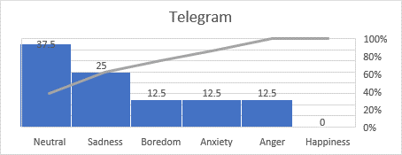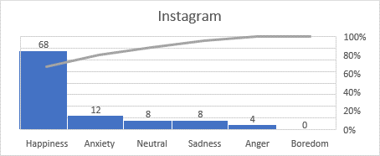Telegram users most common dominant emotion is neutral and least common is happiness with percentage 37.5% and 0% respectively.

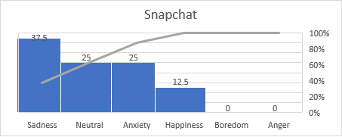The user of snapchat platform found to have sadness as their most common dominant emotion. Which is 37.5 percent. Whereas boredom and anger have 0 percent.

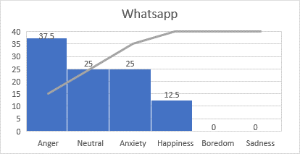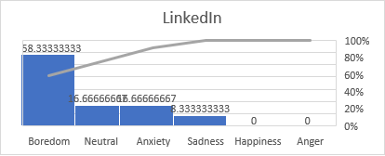LinkedIn user have boredom as their most common dominant emotion with percentage 58.33. whereas happiness and anger have 0 percentage.

whereas WhatsApp users have anger as the most common and boredom and sadness as least common dominant emotion.

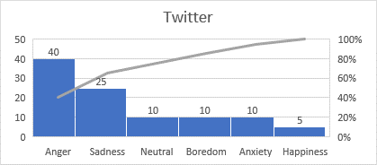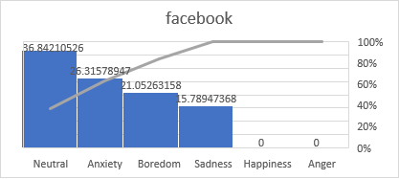Facebook users have neutral as the most common dominant emotion and has a percentage 36.84. whereas happiness and anger are least common.

Twitter user have Anger as most common and happiness as least common dominant emotion.

# Correlation:

The mean, standard error, sample variance and standard deviation of the Usage of social media per day in minutes in given below:

|  |  |
| --- | --- |
| Mean | 95.95 |
| Standard Error | 1.22855885 |
| Median | 85 |
| Mode | 90 |
| Standard Deviation | 38.8504422 |

The dominant emotions are divided into 6 categories. Happiness, neutral, boredom, sadness, anger and anxiety. I organized these emotions from worst to best and assigned them a number from 1 to 6. To find the coefficient of correlation between usage of social media and emotions.

|  |  |
| --- | --- |
| 1 | Anxiety |
| 2 | Anger |
| 3 | Sadness |
| 4 | Boredom |
| 5 | Neutral |
| 6 | Happiness |

The coefficient of the correlation is: 0.319729782

Which shows there is a weak correlation between these two variables. The more the user use social media the better his emotion rank gets but there is a very weak relation.

# Hypothesis testing:

1. THE USERS HAVING HAPPINESS AS THEIR DOMINANT EMOTION HAVE MEAN AGE GREATER THAN 25:

**Null hypothesis:** users having happiness as their dominant emotion have mean age greater than 25.

**Alternative hypothesis:** users having happiness as their dominant emotion have mean age less than equal to 25.

**Level of significance:** 0.01

**Test statistics:**

$$z=\frac{age mean-25}{σ/{\sqrt{n}}}$$

Z= 10.53125

Za= 2.326348

**Conclusion:** z is not smaller than -za hence we accept our null hypothesis. The user having happiness as their dominant emotion have mean age greater than 25.

1. THE USER WITH DOMINANT EMOTION AS ANXIETY HAS A MEAN AGE LESS THAN 28:

**Null hypothesis:** users having anxiety as their dominant emotion have mean age less than 28.

**Alternative hypothesis:** users having anxiety as their dominant emotion have mean age greater than equal to 25.

**Level of significance:** 0.01

**Test statistics:**

$$z=\frac{age mean-28}{σ/{\sqrt{n}}}$$

Z= -0.73311

Za= 2.326348

**Conclusion:** z is smaller than za hence we accept our null hypothesis. The user having anxiety as their dominant emotion have mean age less than 28

# Conclusion:

After the analysis of this dataset, we can conclude that:

Happiness and neutral emotion are the most common among the user of the social media with percentage 20%.

37% of the social media users were female, 36% were male and 27% were non binary.

In male and females, the happiness has the highest percentage of 19.44% and 29.73% respectively. While in non-binary neutral emotion has the most percentage (33%).

The most common social media platform was Instagram with 25% users.

The time spend on social media platform and dominant emotions are weakly related with coefficient of the correlation of 0.319729782.

It was concluded that the user having happiness as their dominant emotion have mean age greater than 25 and the user having anxiety as their dominant emotion have mean age less than 28.